QUIZ RESULTS
MODULE6: MATRIX FACTORIZATION

No. | Quiz title | Completion Status | Score | Coursera link
1 | Module6_1_Non Negative Matrix Factorization | Completed | 100% | Quiz 1
2 | Module6_2_Module 6 Quiz | Completed | 100% | Quiz 2

Module6_1_Non Negative Matrix Factorization
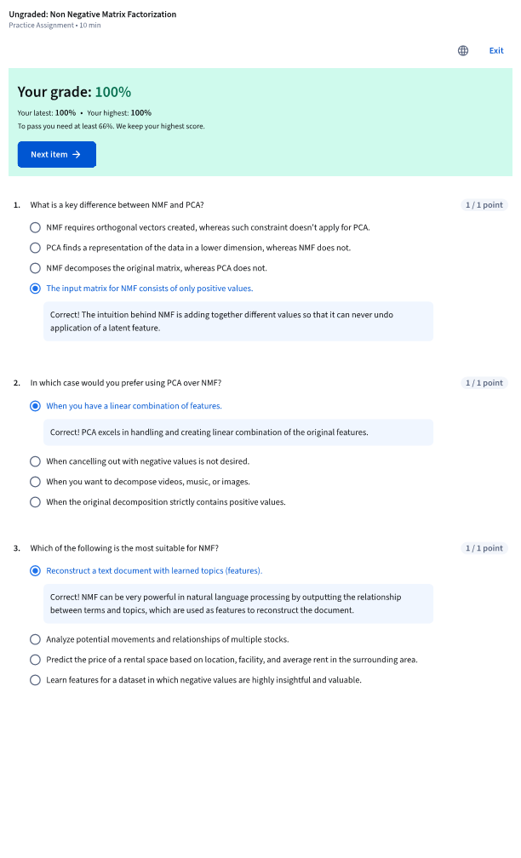

Module6_2_Module 6 Quiz
